|  |  |  |
| --- | --- | --- |
|  | Juan Velasco  Miguel Ángel Sánchez | [juan.velascoi@estudiante.uam.es](mailto:juan.velascoi@estudiante.uam.es)  *miguelangel.sanchezm@estudiante.uam.es* |

TEST PLAN and test results

Application: **RentingJ&MA**

DATE: 11/05/2018

# 1. TEST CASE: BUY OffeR

* 1. **­Use Case:**

**Primary Actor:** Registered user. Guest.

**Stakeholders and Goals:**

* Guest user: Buy an offer for a house

**Preconditions:** The user is identified and login as a guest. The user has searched the offer that he wants to buy.

**Success guarantee (Post-conditions):** The guest buys an offer; the payment system has accepted the credit card and the offer is now bought.

**Main Success Scenario:**

1. The user selects buy offer
2. The system checks if the offer is available to buy
3. The payment system checks if the credit card is reliable
4. The offer is checked as bought and it’s included in the register

**Extensions (Alternative Paths):**

2a. The offer is not available:

2a.1 The system denies the user to buy the house

4a. The payment system detects that the credit card is false.

4a.1 The system blocks the user and when he logs out, he can’t enter anymore in the system (In order to block a user, his credit card is changed, he will need to contact an admin to change the card again and be unblocked)

**Special Requirements:**

* None

**Technology and Data Variations List:**

* Option to download the offer in PDF

**Frequency:**

* Very high, in the order of thousands of concurrent users in different offers

**Open Issues:**

* The guess and the host can’t talk about the offer

**1.2. Test case design:**

**Preconditions:**

* A guest user must be logged
* There must be a house and an offer to be bought
* The guest had searched and select an offer before

**Main Success Scenario:**

1. The user clicks on “Buy” button

2. System shows an extern panel

3. The user introduces the subject and click accept

4. The system makes the payment

5. The system shows a panel showing that the offer has been bought (The offer view stays the same)

**Extensions (Alternative Paths):**

3.1 The user presses cancel

3.1.1 The offer stays available and the offer is shown

4.1 The offer is already bought

4.1.1 The system shows a panel with the error and the offer is not bought

4.2 The offer is already reserved by another user

4.2.1 The system shows a panel with the error and the offer is not bought

4.3 The payment system fails

4.3.1 The system shows a panel with the error type and the offer is not bought

4.4 The user credit card is not valid

4.4.1 The system bans the user and tell the user that is banned. It let the user to continue with the actual session

## 1.3. Test execution result

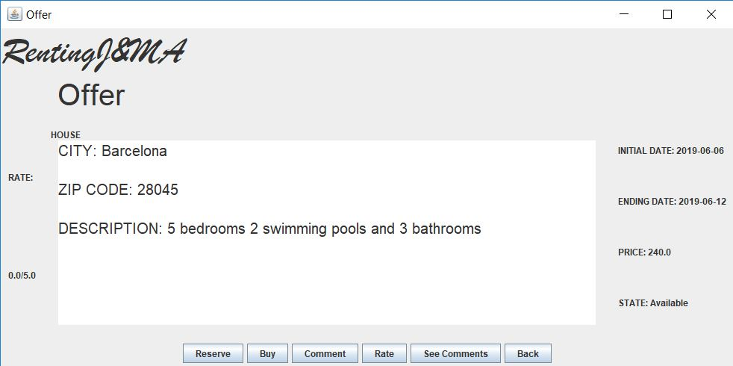

If the user selects ‘buy’ a window will pop up and tell him to introduce the subject.

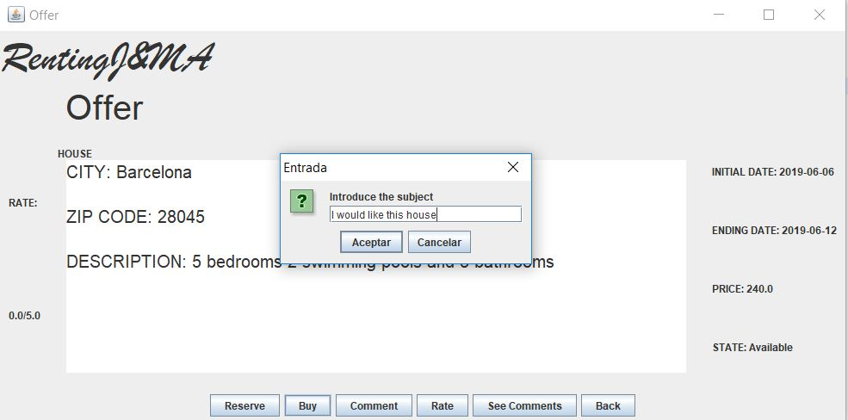

When the user writes the subject and presses ‘Aceptar’, if everything goes correctly a window will pop up and say, ‘You have bought the offer’.

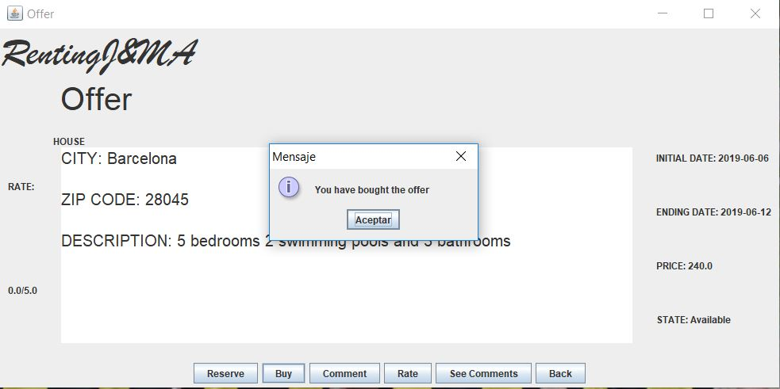

So now the offer has successfully been bought.

**Now we are going to see the alternative paths:**

In all these alternative paths there is an error and the user can’t buy the offer.

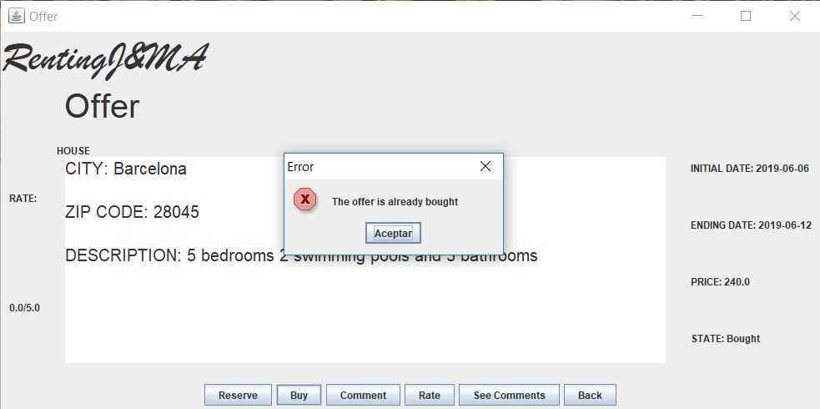

This is the error that appears if the offer has already been bought.

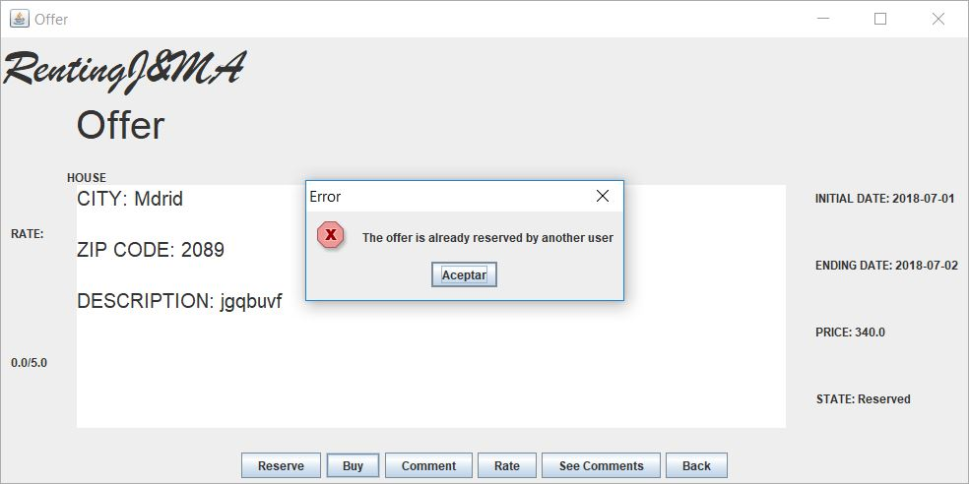

This is the error that appears if the offer has been reserved.

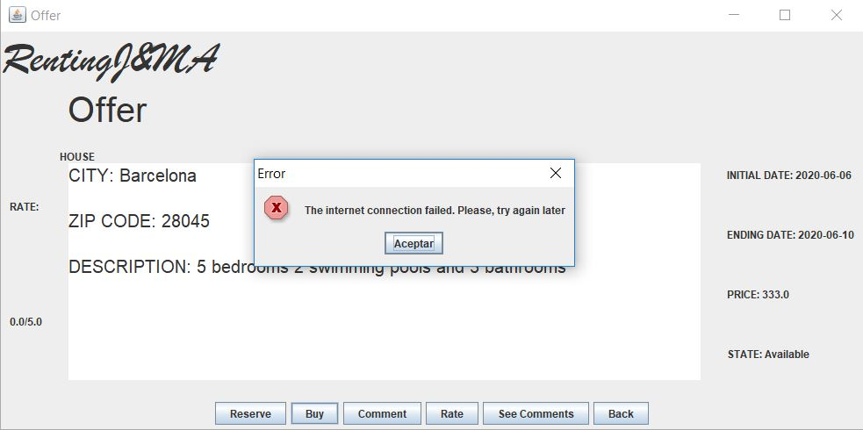

This is the error that appears if there is an error in the payment system

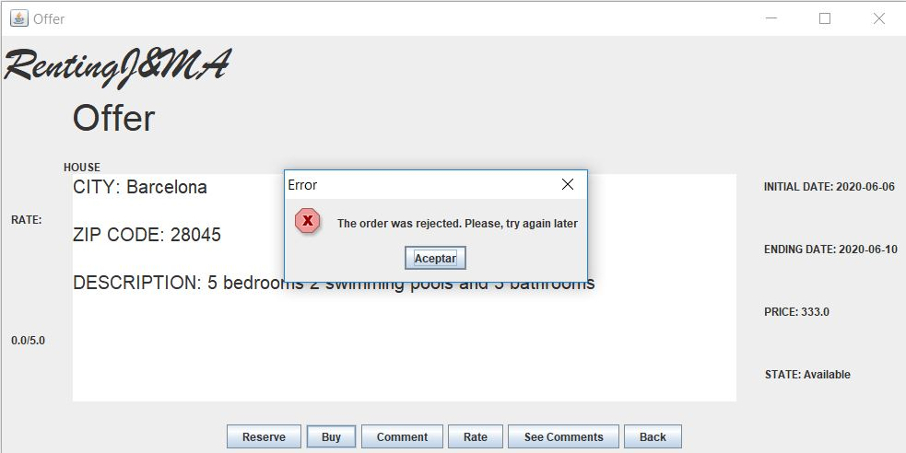

This is another error with the payment system.

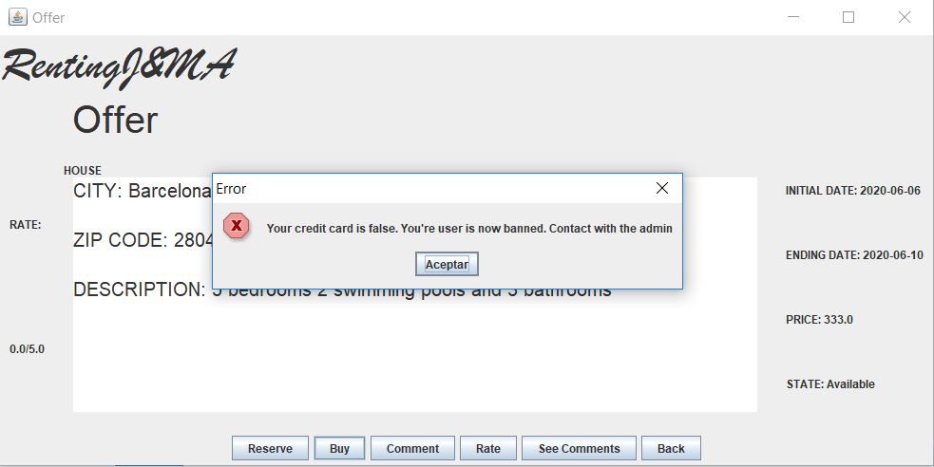

And this is what appears if your credit card is incorrect.

**Conclusion:**

As we can see in the views, we can make all the different paths with our application. The only thing that could be done better is the actualization of the state in real time. So, we can say that our application passes the buy offer test.

# 2. TEST CASE CREATE A living OFFER

**2.1 Use case:**

**Primary Actor:** Registered user. Host

**Stakeholders and Goals:**

* Host user: Put an offer to his house

**Preconditions:** The user is identified and login as a host. The host needs to have a house uploaded.

**Success guarantee (Post-conditions):** The host puts an offer in the system, the admin approves the offer and it’s published in the system.

**Main Success Scenario:**

1. The user selects “create offer”
2. The user chooses the house
3. The user chooses the type living for the offer
4. The user introduces the price for the offer and submits to the admin
5. The system stores the offer to notify the admin

**Extension (Alternative Paths):**

4b. The user doesn’t introduce some information:

4b.1 The system asks the user to enter the missing information, going back to the step 1.

**Special Requirements:**

* None

**Technology and Data Variations List:**

* If the offer is a living offer, it’s added to the system register

**Frequency:**

* High, in the order of one of concurrent users

**Open Issues:**

* None
  1. **Test case design:**

**Preconditions:**

* A Host user is logged
* The host has added a house
* The host is in his houses view

**Main Success Scenario:**

1. The user selects living and press the make offer button
2. The system shows a new view where the user can introduce the offer parameters
3. The user introduces the initial date, the price and the number of months
4. The user presses the accept button
5. The system checks the parameters and add the offer to the system

**Extensions (Alternative Paths):**

* 1. The user presses the cancel button

4.1.1 The system shows again the houses of the user

5.1 The user doesn’t introduce the date, or the date it isn’t valid

5.1.1 The system shows a message with the date type

5.2 The user doesn’t introduce the price, or the price isn’t valid

5.2.1 The system shows a message telling that the price is wrong

5.3 The user doesn’t introduce the number of months, or they aren’t valid

5.3.1 The system shows a message telling that the months are wrong

* 1. **Test execution result**

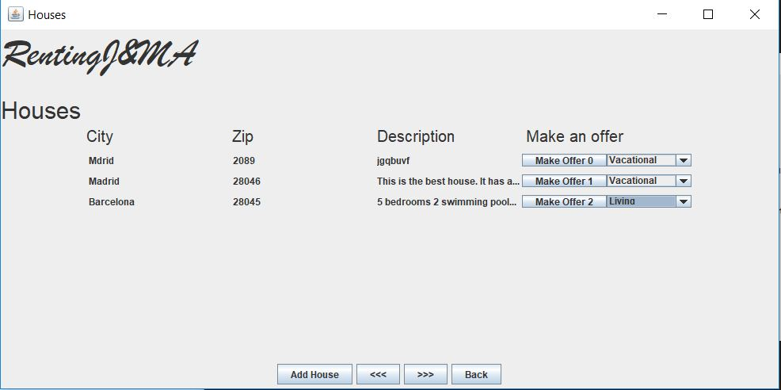

If the user selects ‘living’ in a combo box and presses the button ‘make offer’ next to that combo box, he will see this next window:

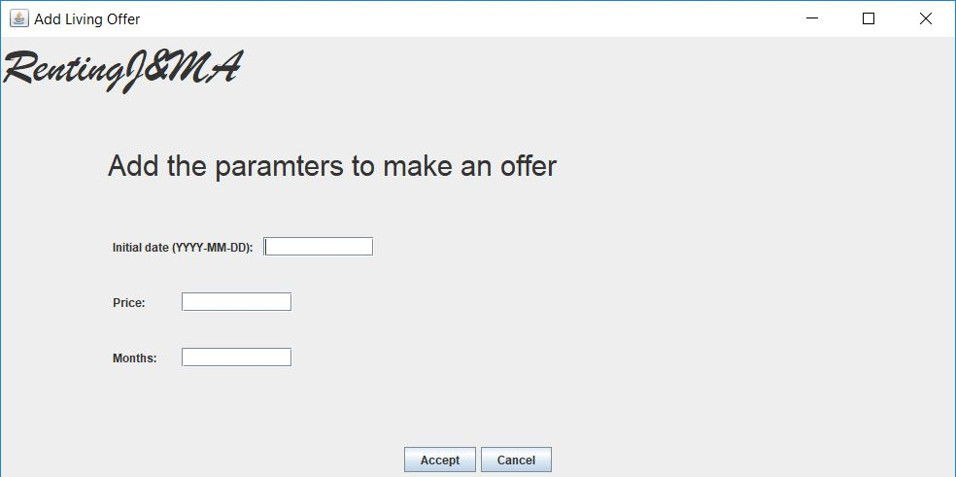

Now he introduces all the data and presses ‘Aceptar’. If everything is correct this next window will pop up:

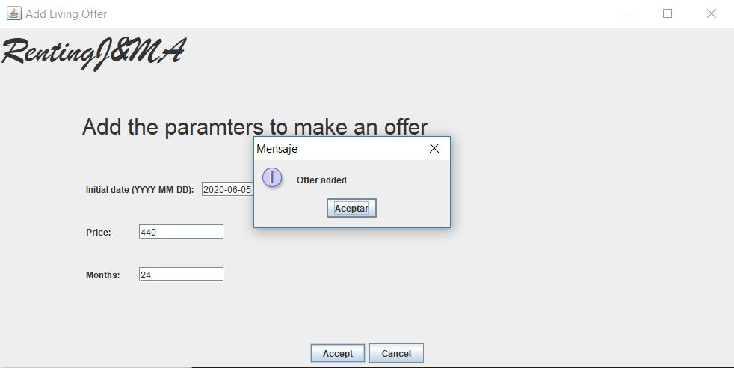

So now the offer has successfully been added.

**Alternative paths.**

In all these alternative paths there is an error and the user can’t add the offer.

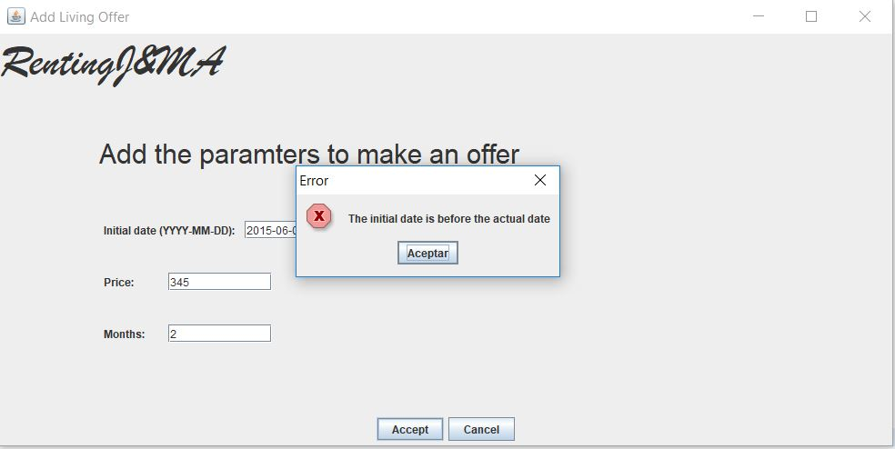

This is the error that appears if the initial date is before the actual date.

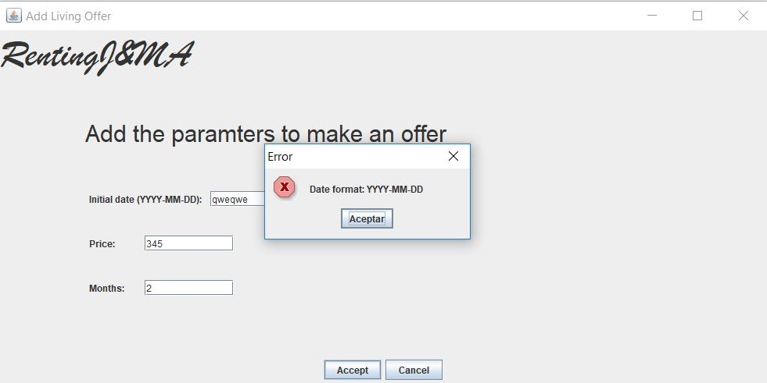

This is the error that appears if the date has an incorrect format.

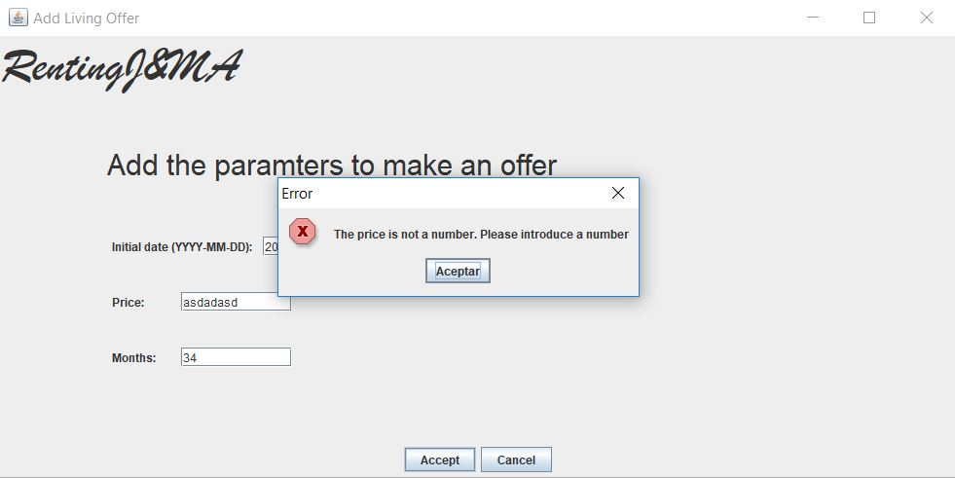

This is the error that appears if the price is not a correct number.

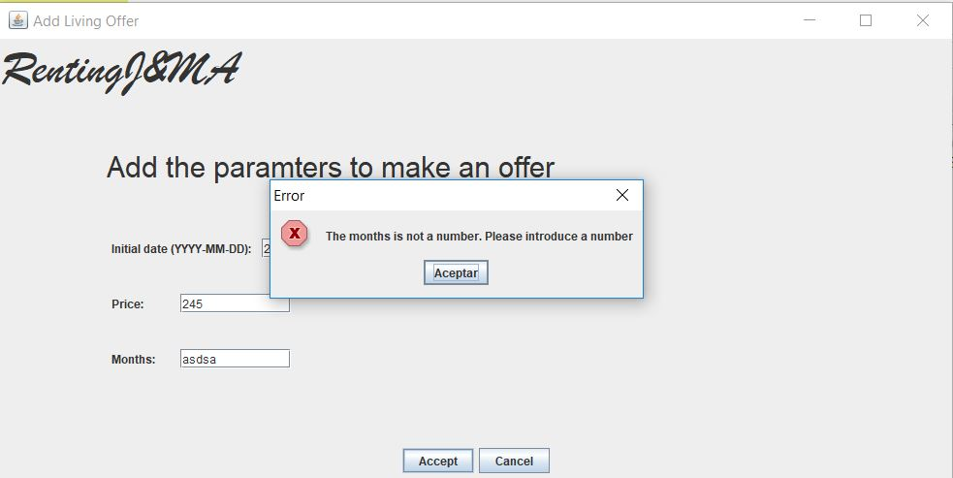

And this is the error that appears if the parameter Months is not a number.

**Conclusions:**

As we can see in the views, we can follow all the paths that we described in the test case design, even the alternative paths. So we can conclude that our application pass the test.